COLLEGE CLUB RESOURCE BOOKING & LOG
@CREATIVITY THINK (9483175986/7019689991)

ABSTRACT:
College Club Resource Booking & Log is a web-based platform designed to manage and monitor the booking and usage of shared resources such as projectors, microphones, banners, and other equipment within college clubs, departments, and seminar halls. The system allows club members to request resource bookings, receive approvals, log actual usage, and provide feedback. Administrators manage resource availability, resolve booking conflicts, track usage trends, and export monthly logs. Built using Django and Django REST Framework for backend operations, and React with react-calendar and axios for frontend interactivity, the platform ensures efficient resource allocation, accountability, and data-driven management..

INTRODUCTION OF THE PROJECT:
College Club Resource Booking & Log is a web-based platform designed to manage and monitor the booking and usage of shared resources such as projectors, microphones, banners, and other equipment within college clubs, departments, and seminar halls. The system allows club members to request resource bookings, receive approvals, log actual usage, and provide feedback. Administrators manage resource availability, resolve booking conflicts, track usage trends, and export monthly logs. Built using Django and Django REST Framework for backend operations, and React with react-calendar and axios for frontend interactivity, the platform ensures efficient resource allocation, accountability, and data-driven management..

PROJECT OBJECTIVES:

• Provide a centralized system for booking and tracking shared resources
• Allow club members to browse available resources and request bookings
• Enable approval or denial of requests by administrators
• Maintain logs of actual resource usage and feedback
• Resolve scheduling conflicts and clashes efficiently
• Provide dashboards showing usage statistics per resource and club
• Allow administrators to export monthly usage logs
• Support transparency, accountability, and data-driven decision-making

PROBLEM OF THE STATEMENT:
College clubs and departments often struggle to manage shared resources due to manual processes, lack of structured booking systems, and insufficient tracking. Scheduling conflicts and mismanagement can lead to wasted resources and member dissatisfaction. The College Club Resource Booking & Log platform solves these problems by providing a structured, digital system to manage bookings, track usage, and analyze trends, ensuring fair and efficient allocation of resources..

MOTIVATION OF THE PROJECT:
• To streamline the process of booking shared resources
• To prevent scheduling conflicts and optimize resource usage
• To provide accurate logs of usage and feedback for accountability
• To enhance transparency in resource allocation
• To offer administrators insights into resource utilization and trends
• To provide a user-friendly interface for both club members and admins
• To reduce manual errors and administrative workload
• To support informed decision-making for resource planning

BLOCK DAIGRAM OF PROJECT:

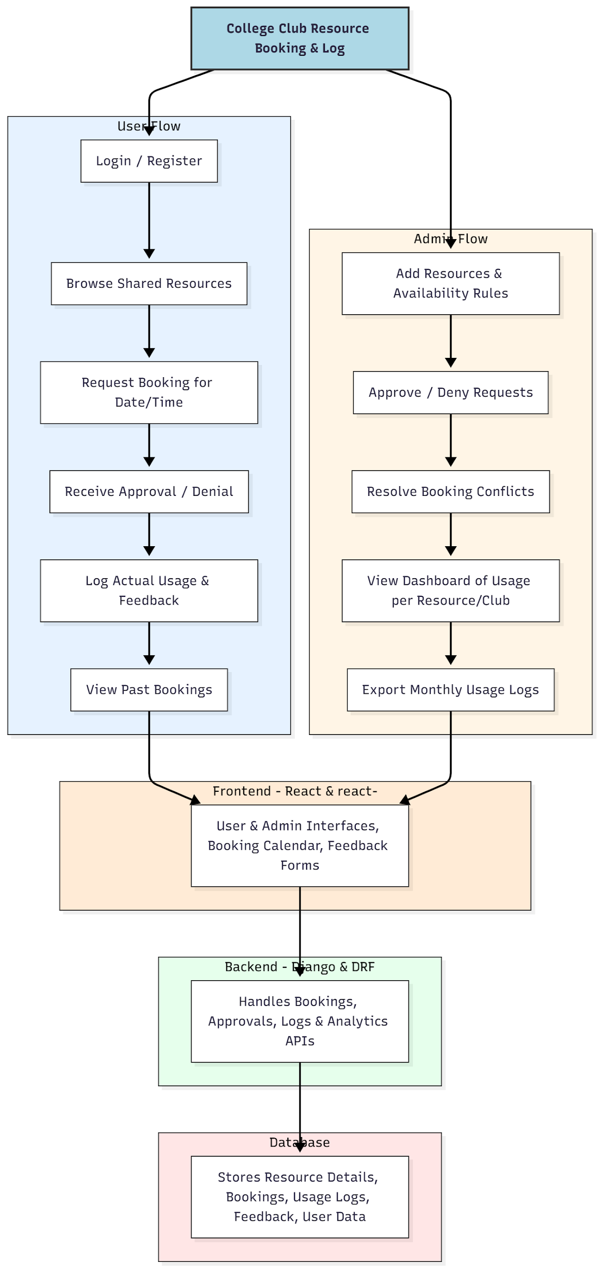

WORKING OF THE PROJECT:
Club members log in to the platform to browse available shared resources. They request bookings for specific dates and times and receive approval or denial notifications from administrators. Upon usage, members log actual usage details and provide feedback. Administrators add resources, define availability rules, approve or reject requests, and resolve conflicts. The dashboard provides analytics for resource utilization per club and resource type, and monthly logs can be exported. The backend ensures smooth API interactions, stores booking and usage data, and generates real-time updates for both members and admins..

SOFTWARE REQUIREMENT:
- Backend:
  - Python 3.x
  - Django
  - Django REST Framework
  - SQLite/PostgreSQL
- Frontend:
  - Node.js and npm
  - React.js
  - Axios
- Development Tools:
  - Visual Studio Code
  - Postman (for testing APIs)
  - Git/GitHub (for version control)
- Server/Deployment (Optional):
  - Gunicorn, Nginx, or Heroku/AWS for hosting

ADVANTAGES OF THE PROJECT:

• Centralized platform for resource booking and usage tracking
• Reduces conflicts and optimizes shared resource usage
• Provides accurate logs and feedback for accountability
• Dashboard analytics for informed administrative decisions
• Real-time notifications and status updates for members
• Streamlines administrative workflow and reduces manual work
• Supports multiple clubs and resource types
• Enhances transparency and efficient planning

APPLICATIONS OF THE PROJECT:
• College and university clubs
• Departmental resource management
• Seminar halls and event spaces
• Any shared resource allocation system in educational institutes

REFERENCES:

- Django REST Framework Documentation — Django Software Foundation. Django Documentation. Available: https://docs.djangoproject.com/
- Django REST Framework. DRF Documentation. Available: https://www.django-rest-framework.org/
- React. React Official Documentation. Available: https://reactjs.org/docs/getting-started.html
- Redux. Redux Documentation. Available: https://redux.js.org/introduction/getting-started
- PostgreSQL Global Development Group. PostgreSQL Documentation. Available: https://www.postgresql.org/docs/
- MySQL. MySQL Reference Manual. Available: https://dev.mysql.com/doc/
- Git. Git Documentation. Available: https://git-scm.com/doc
- Node.js. Node.js Documentation. Available: https://nodejs.org/en/docs/
- Axios. Axios Documentation. Available: https://axios-http.com/docs/intro
- Socket.io Documentation – https://socket.io/docs/

